Authentication Migration

🌟 Definition
# Source: AI Source: Provided by: [Data Path: Persons Table -> ID Column: 1, Name_En Column: Motasem Essam] -> From: [ChatGPT] on [6/7/2026]
Authentication Migration is the process of changing the authentication mechanism used to access an API while keeping the API's business functionality the same.
The migration involves moving from one authentication method to another to improve security, scalability, compliance, or user experience.

🎯 Purpose
# Source: AI Source: Provided by: [Data Path: Persons Table -> ID Column: 1, Name_En Column: Motasem Essam] -> From: [ChatGPT] on [6/7/2026]
Organizations perform authentication migration to:
- Improve security
- Meet compliance requirements
- Support modern authentication standards
- Enable Single Sign-On (SSO)
- Improve access control
- Replace deprecated authentication methods

🧠 Simple Definition
# Source: AI Source: Provided by: [Data Path: Persons Table -> ID Column: 1, Name_En Column: Motasem Essam] -> From: [ChatGPT] on [6/7/2026]
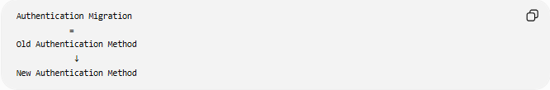
Authentication Migration
=
Old Authentication Method
↓
New Authentication Method

📚 What is Authentication?
# Source: AI Source: Provided by: [Data Path: Persons Table -> ID Column: 1, Name_En Column: Motasem Essam] -> From: [ChatGPT] on [6/7/2026]
Authentication is the process of verifying the identity of a user, application, or system before allowing access to an API.
Examples:
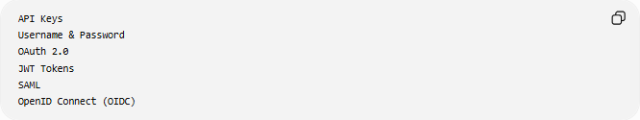
API Keys
Username & Password
OAuth 2.0
JWT Tokens
SAML
OpenID Connect (OIDC)

🔍 Basic Example
# Source: AI Source: Provided by: [Data Path: Persons Table -> ID Column: 1, Name_En Column: Motasem Essam] -> From: [ChatGPT] on [6/7/2026]
Before
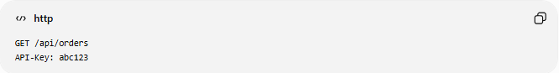
GET /api/orders
API-Key: abc123

After
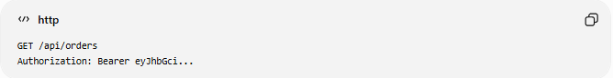
GET /api/orders
Authorization: Bearer eyJhbGci...
The API endpoint remains the same, but the authentication method changes.

🏗️ Common Authentication Migrations

1️⃣ API Key → OAuth 2.0
# Source: AI Source: Provided by: [Data Path: Persons Table -> ID Column: 1, Name_En Column: Motasem Essam] -> From: [ChatGPT] on [6/7/2026]
Before
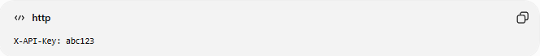
X-API-Key: abc123

After
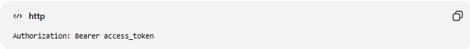
Authorization: Bearer access_token
Benefits:
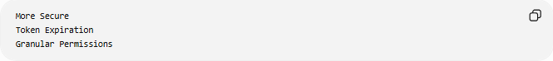
More Secure
Token Expiration
Granular Permissions

2️⃣ Basic Authentication → OAuth 2.0
# Source: AI Source: Provided by: [Data Path: Persons Table -> ID Column: 1, Name_En Column: Motasem Essam] -> From: [ChatGPT] on [6/7/2026]
Before
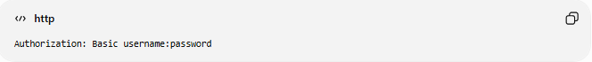
Authorization: Basic username:password

After
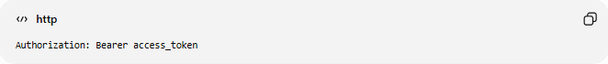
Authorization: Bearer access_token
Benefits:
No Password Transmission
Better Security

3️⃣ Session Authentication → JWT
# Source: AI Source: Provided by: [Data Path: Persons Table -> ID Column: 1, Name_En Column: Motasem Essam] -> From: [ChatGPT] on [6/7/2026]
Before
Server Stores User Session

After
JWT Stored by Client
Benefits:
Stateless Authentication
Better Scalability

4️⃣ Legacy Identity System → Single Sign-On (SSO)
# Source: AI Source: Provided by: [Data Path: Persons Table -> ID Column: 1, Name_En Column: Motasem Essam] -> From: [ChatGPT] on [6/7/2026]
Before
Separate Login for Each Application

After
One Login
Multiple Applications
Benefits:
Better User Experience
Centralized Security

🛠️ Real-World Example
# Source: AI Source: Provided by: [Data Path: Persons Table -> ID Column: 1, Name_En Column: Motasem Essam] -> From: [ChatGPT] on [6/7/2026]
Before Migration
An API uses API Keys.
Request:
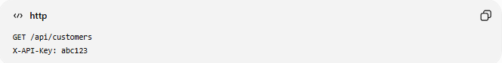
GET /api/customers
X-API-Key: abc123

Problems:
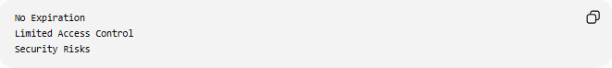
No Expiration
Limited Access Control
Security Risks

After Migration
The API uses OAuth 2.0.
Request:
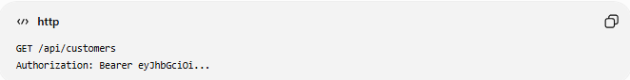
GET /api/customers
Authorization: Bearer eyJhbGciOi...
Benefits:
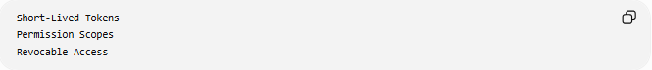
Short-Lived Tokens
Permission Scopes
Revocable Access

🔄 Authentication Migration Lifecycle
# Source: AI Source: Provided by: [Data Path: Persons Table -> ID Column: 1, Name_En Column: Motasem Essam] -> From: [ChatGPT] on [6/7/2026]
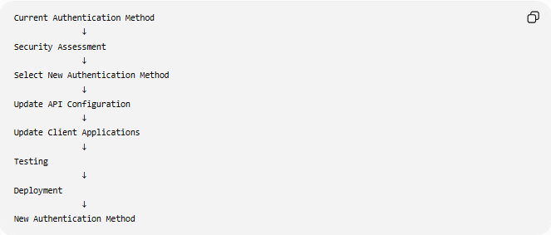
Current Authentication Method
↓
Security Assessment
↓
Select New Authentication Method
↓
Update API Configuration
↓
Update Client Applications
↓
Testing
↓
Deployment
↓
New Authentication Method

📦 Common Authentication Technologies
# Source: AI Source: Provided by: [Data Path: Persons Table -> ID Column: 1, Name_En Column: Motasem Essam] -> From: [ChatGPT] on [6/7/2026]
API Keys
Simple token-based authentication.
Example:
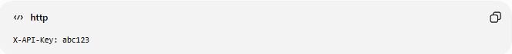
X-API-Key: abc123

Basic Authentication
Uses username and password.
Example:
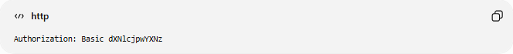
Authorization: Basic dXNlcjpwYXNz

OAuth 2.0
Industry-standard authorization framework.
Example:
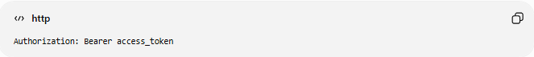
Authorization: Bearer access_token

JWT (JSON Web Token)
Self-contained authentication token.
Example:
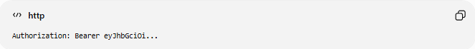
Authorization: Bearer eyJhbGciOi...

OpenID Connect (OIDC)
Identity layer built on OAuth 2.0.
Provides:
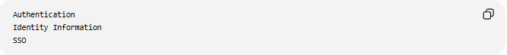
Authentication
Identity Information
SSO

SAML
Enterprise authentication protocol often used for SSO.

🌍 Example Migration Scenario
# Source: AI Source: Provided by: [Data Path: Persons Table -> ID Column: 1, Name_En Column: Motasem Essam] -> From: [ChatGPT] on [6/7/2026]
Before
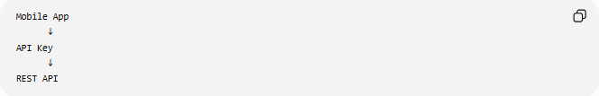
Mobile App
↓
API Key
↓
REST API

After
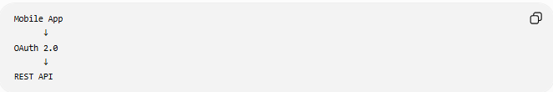
Mobile App
↓
OAuth 2.0
↓
REST API
The API remains the same, but authentication becomes more secure.

⚠️ Common Challenges
# Source: AI Source: Provided by: [Data Path: Persons Table -> ID Column: 1, Name_En Column: Motasem Essam] -> From: [ChatGPT] on [6/7/2026]
Token Management
Applications must:
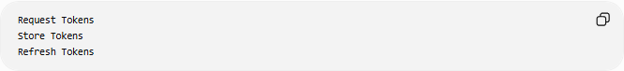
Request Tokens
Store Tokens
Refresh Tokens

Client Updates
Every application using the API must be modified.

Backward Compatibility
Older clients may still depend on the old authentication method.

User Migration
Users may need to:
Reauthenticate
Reset Credentials

Integration Testing
Authentication flows must be thoroughly tested.

📊 Example Comparison
# Source: AI Source: Provided by: [Data Path: Persons Table -> ID Column: 1, Name_En Column: Motasem Essam] -> From: [ChatGPT] on [6/7/2026]
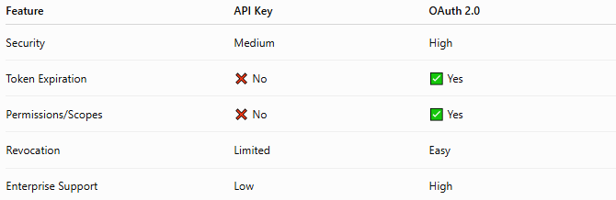
Feature | API Key | OAuth 2.0
Security | Medium | High
Token Expiration | ❌ No | ✅ Yes
Permissions/Scopes | ❌ No | ✅ Yes
Revocation | Limited | Easy
Enterprise Support | Low | High

✅ Benefits
# Source: AI Source: Provided by: [Data Path: Persons Table -> ID Column: 1, Name_En Column: Motasem Essam] -> From: [ChatGPT] on [6/7/2026]
Stronger Security
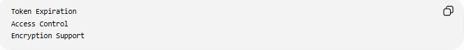
Token Expiration
Access Control
Encryption Support

Better Compliance
Supports standards required by:
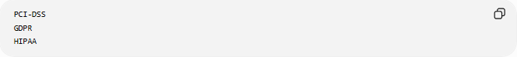
PCI-DSS
GDPR
HIPAA

Improved Scalability
Stateless Authentication
Distributed Systems

Better User Experience
Single Sign-On (SSO)
Centralized Login

Fine-Grained Permissions
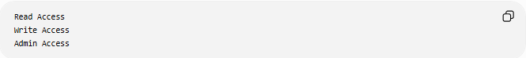
Read Access
Write Access
Admin Access

📊 Authentication Migration vs API Version Migration
# Source: AI Source: Provided by: [Data Path: Persons Table -> ID Column: 1, Name_En Column: Motasem Essam] -> From: [ChatGPT] on [6/7/2026]
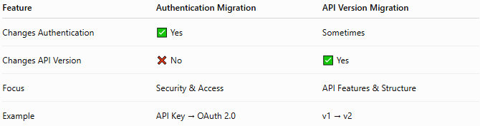
Feature | Authentication Migration | API Version Migration
Changes Authentication | ✅ Yes | Sometimes
Changes API Version | ❌ No | ✅ Yes
Focus | Security & Access | API Features & Structure
Example | API Key → OAuth 2.0 | v1 → v2

Authentication Migration
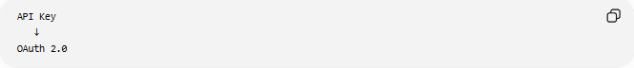
API Key
↓
OAuth 2.0

API Version Migration
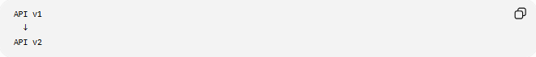
API v1
↓
API v2

🛠️ Common Authentication Platforms
# Source: AI Source: Provided by: [Data Path: Persons Table -> ID Column: 1, Name_En Column: Motasem Essam] -> From: [ChatGPT] on [6/7/2026]
- OAuth 2.0
- OpenID Connect
- JSON Web Token
- SAML
- Keycloak
- Okta
- Auth0

🧠 Simple Analogy
# Source: AI Source: Provided by: [Data Path: Persons Table -> ID Column: 1, Name_En Column: Motasem Essam] -> From: [ChatGPT] on [6/7/2026]
Imagine replacing the lock system of a building.
Before
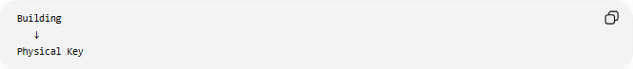
Building
↓
Physical Key

After
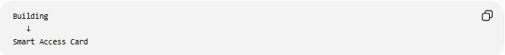
Building
↓
Smart Access Card
The building remains the same, but the way people gain access changes.
Authentication migration works similarly:
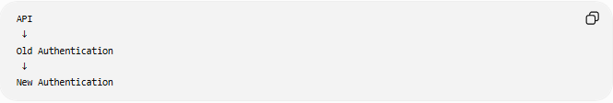
API
↓
Old Authentication
↓
New Authentication
while keeping the API's functionality unchanged.

🧭 Summary
# Source: AI Source: Provided by: [Data Path: Persons Table -> ID Column: 1, Name_En Column: Motasem Essam] -> From: [ChatGPT] on [6/7/2026]
Authentication Migration is a type of API migration that changes how users, applications, or systems authenticate when accessing an API. Examples include API Key → OAuth 2.0, Basic Authentication → JWT, and Legacy Authentication → SSO. The primary goals are improving security, supporting modern standards, enabling centralized identity management, and providing better access control while keeping the API's business functionality intact.

